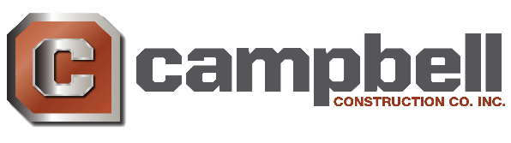

**NOW HIRING EXPERIENCED HEAVY EQUIPMENT OPERATORS!**

Locally owned & operated general contractor looking for experienced operators to join our team. Our jobs are local to the Reno, NV area (Spanish Springs to Dayton Nevada).

**Qualifications and Requirements:**

* Dependable
* Good work ethic
* Positive Attitude
* Think safety on and off the job
* Ability to safely operate heavy equipment
* Osha 10- You have 15 days from start date to obtain your Osha 10
* Pass Pre-employment drug test
* Reliable transportation

**Equipment Knowledge:**

* Dozers
* Scrapers
* Blades
* Compactors
* Excavators
* Loader
* Backhoes
* Haul Trucks

**Benefit Package:**

* Health, Dental, & Vision with 50% of the total premium of base plan covered
* 401K plan after 1 year, with employer matching
* Aflac- Supplemental insurance
* Earn up to 1-week paid vacation a year
* Weekly paycheck
* Overtime weekly

**Pay Scale:** $20-40 an hour

If this position interests you please come into our office to fill out an application, or email a resume to email on file. If you have any additional questions call our office at 775-677-9111.

**We look forward to hearing from you!**